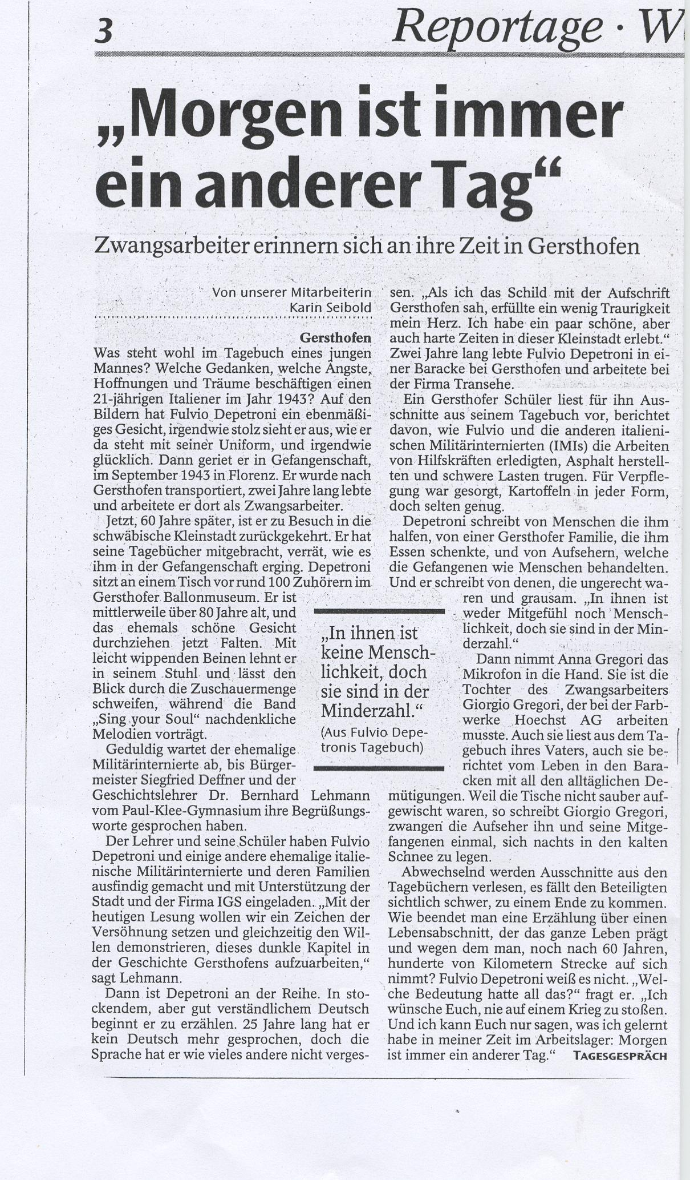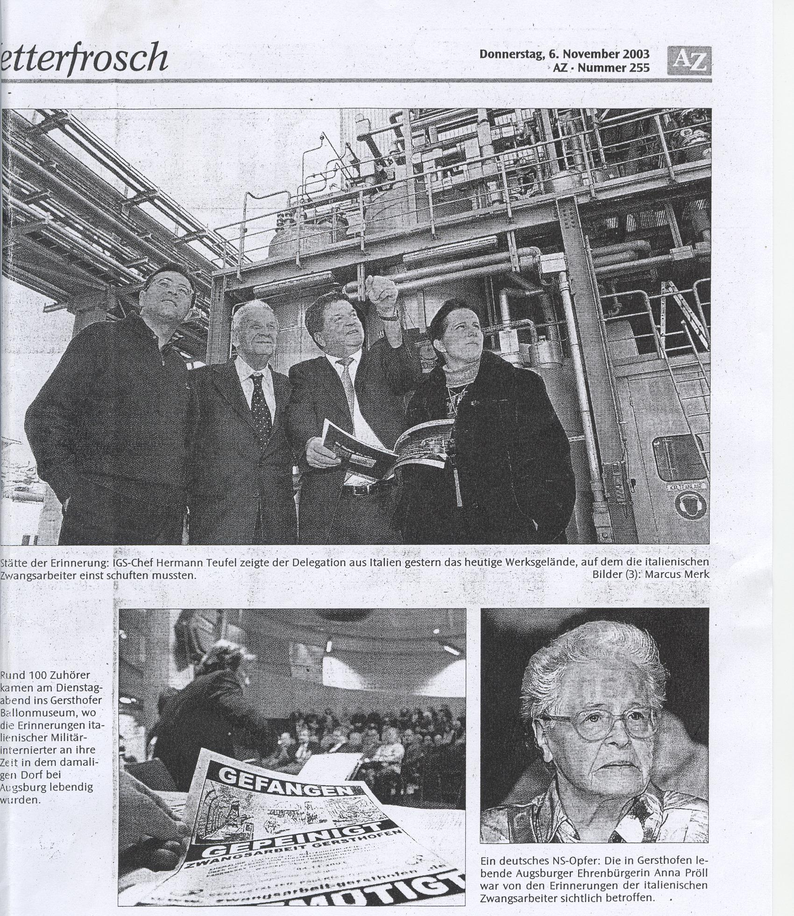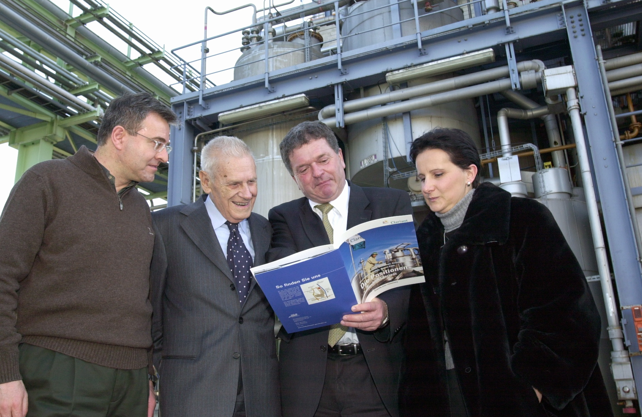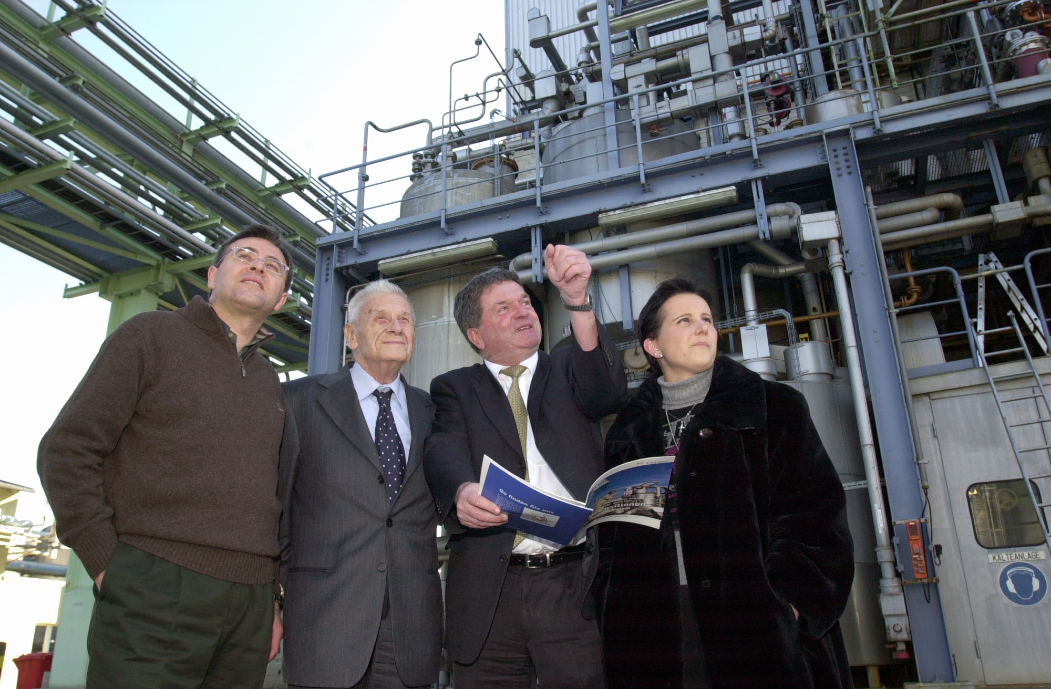
Guido Giachetti, Fulvio Depetroni, Hermann Teufel (IG Farbwerke Hoechst), Anna Gregori at their visit at Farbwerke Hoechst AG in Gersthofen
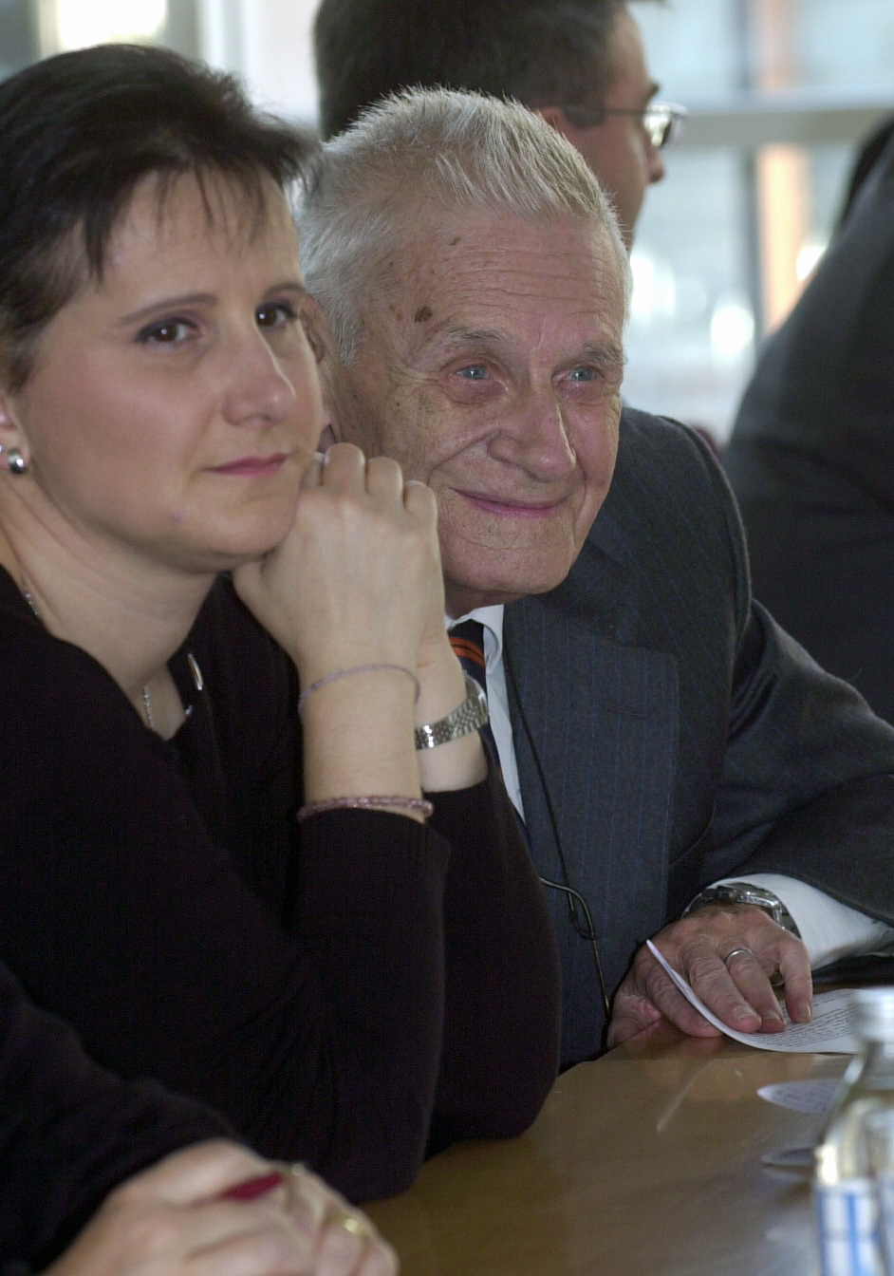
Anna Gregori and Fulvio Depetroni, at Paul-Klee-Grammar School, 4.11.2003
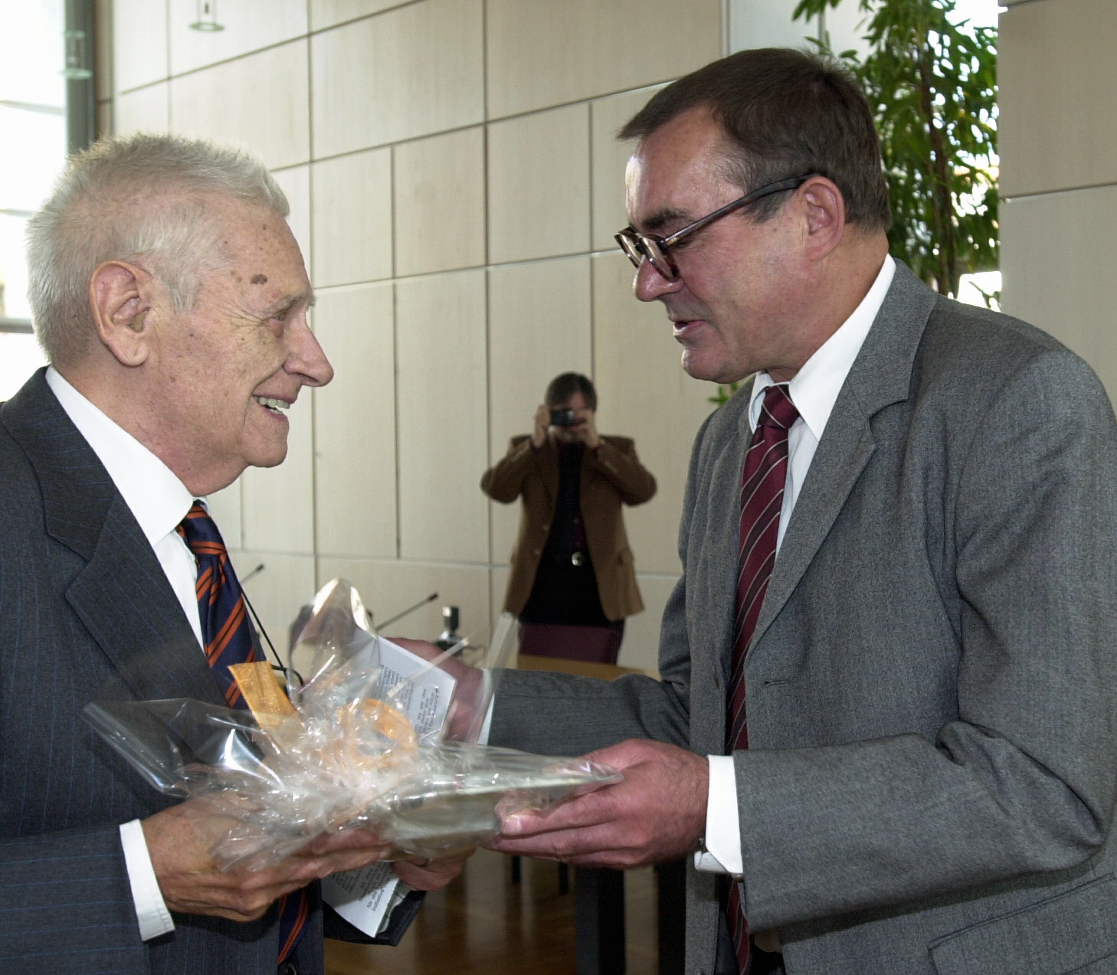
Fulvio Depetroni with the mayor of Gersthofen, Siegfried Deffner 4.11.2003

